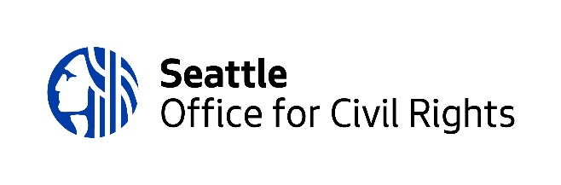

[**Civil Rights Now**](https://ocr.seattle.gov/)

**June 2022**

***City Racial Equity Actions: 2022 Highlights***

*Image Description for Word Chart Diagram*

Two gray word bubbles with terms of different sizes. The terms are in black or teal.

Largest terms:

* Community Organizations
* Community Partners
* Employees
* RSJI Change Team

Second largest terms:

* Businesses
* Communities Most Impacted
* Community Advisory Board/Committee
* Leadership
* OCR
* WMBE

Third largest terms:

* BIPOC Community Organizations
* Community Advisory Group
* Consultants
* Customers
* Employee Caucus/Affinity Group
* Grant Applicants
* IDT
* OIRA
* Public: Website, Emails, Calls, Texts
* RET
* SDHR

Smallest terms:

* BIPOC Businesses
* BIPOC Residents
* BIPOC Workers
* CBO
* Community Committee
* Contractors
* Mayor’s Office
* Other Government Agencies
* SDHR Training and Development
* WEPAC